**Comparison between Adjacency List and Matrix**

**Adjacency List:**

An Adjacency list is an *array consisting of the address of all the linked lists*. The first node of the linked list represents the vertex and the remaining lists connected to this node represents the vertices to which this node is connected. This representation can also be used to represent a weighted graph. The linked list can slightly be changed to even store the weight of the edge.

**storage:** overall space complexity is O(|V|+|E|).

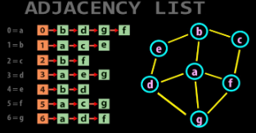

**Adjacency Matrix:**

Adjacency Matrix is *a 2D array of size V x V where V is the number of vertices in a graph*. Let the 2D array be adj[][], a slot adj[i][j] = 1 indicates that there is an edge from vertex i to vertex j. Adjacency matrix for undirected graph is always symmetric. Adjacency Matrix is also used to represent weighted graphs. If adj[i][j] = w, then there is an edge from vertex i to vertex j with weight w.

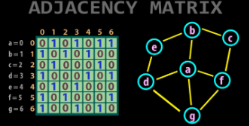**storage:** representation makes use of V x V matrix, so space required in worst case is O(|V|^2).